I’m following these instructions to create enhancement request.

https://knowledge.broadcom.com/external/article?articleId=9731

In this case I need to create it for Agile Requirements Designer (ARD), however, in the categories list box field I don’t have ‘Agile Requirements Designer’ available despite the fact that I can see hundred of other products/solutions. I have credentials to create support cases for Agile Requirements Designer, so I don’t understand why I can’t see it in ARD Community in the Ideas section?

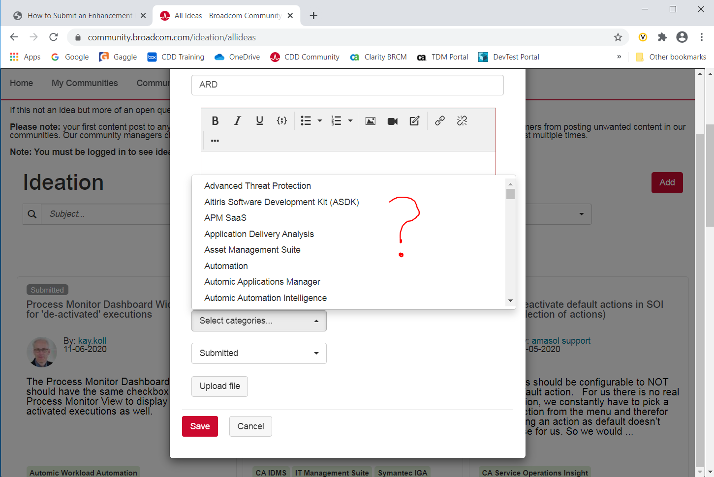

This is what I should be seeing, but it is not available for me:

