How to do Full Text Searches against DocOps Documentation

Overview
This example will be to download all of the CA Service Management - 17.2 documentation, and use Adobe Acrobat to conduct a full text search on it.
Caution: The downloaded document will not be a “live” document.
Please use the DocOps documentation where currency is required. This method best suits data that does not change significantly over the longer term, or where the latest news is not essential. Please open the DocOps documentation to check for any updates if performing any significant task, such as an upgrade.
This overcomes the issue that search engines only index the first part of pages. They will not find terms near the end of pages, such as this one: usm-udm:OriginatingURL
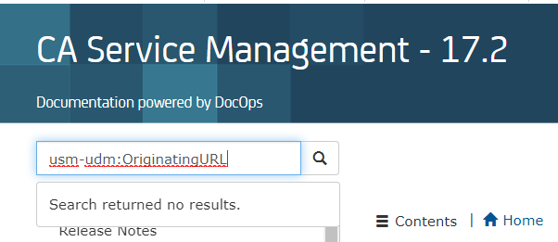

Steps

1. Open the DocOps documentation

Navigate to the relevant product documentation home page.
https://docops.ca.com/ca-service-management/17-2/en
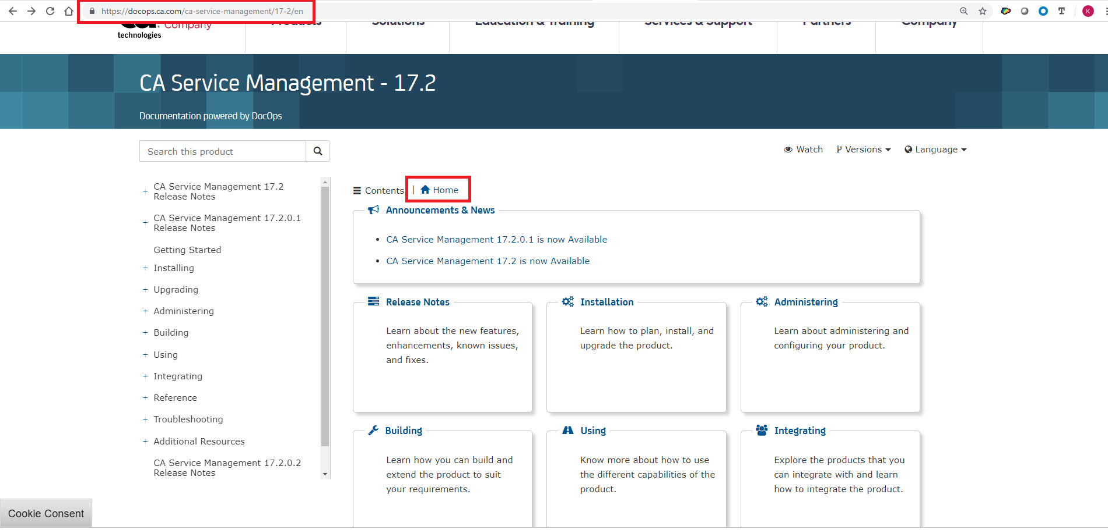

2. Open all document sections

Right click and Open in a New Tab each section that you wish to have in your final document.
For this example, we will download everything except the “Announcements” section.

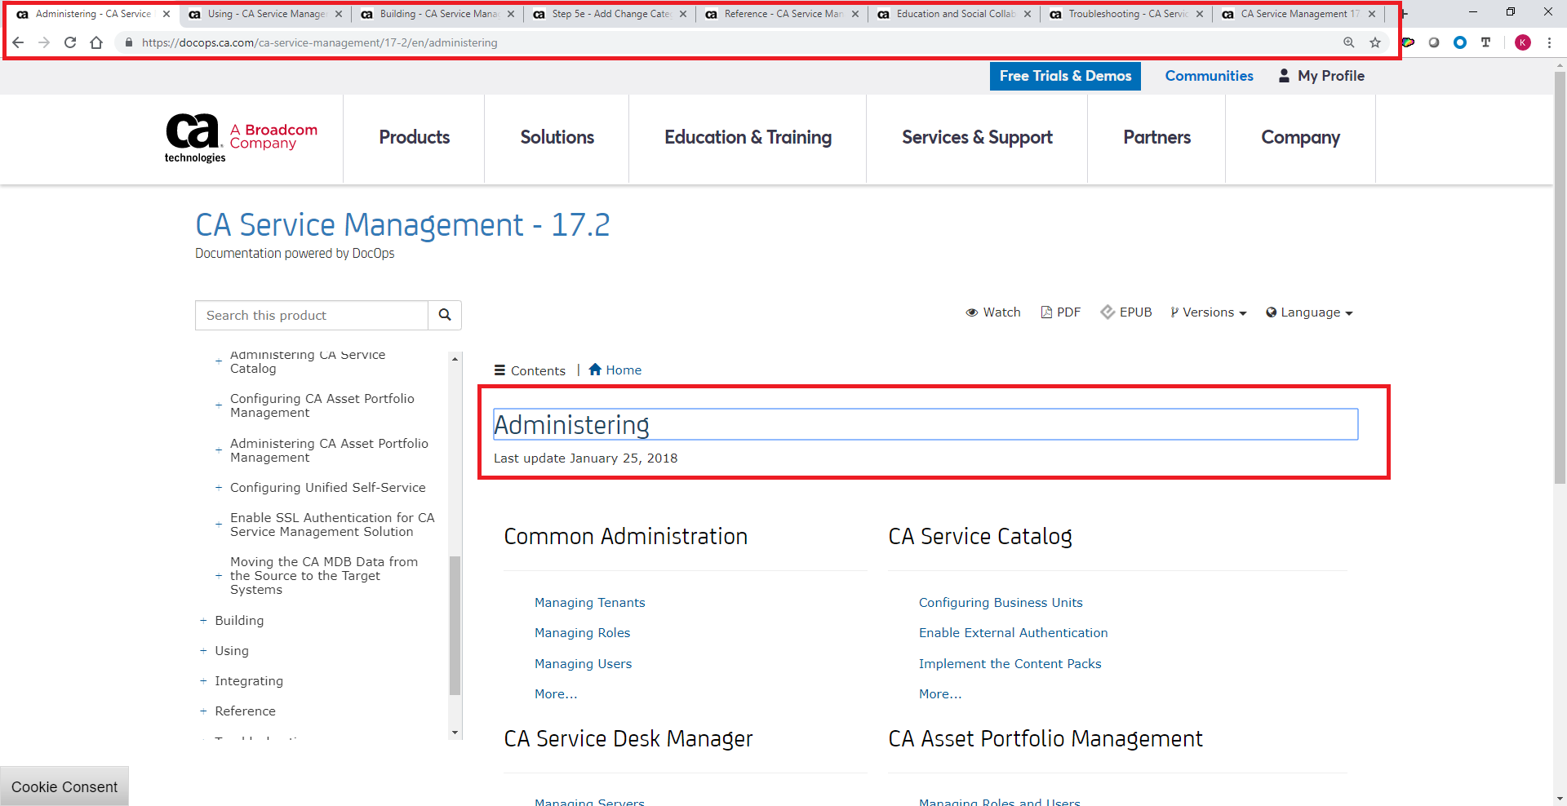

3. Download each PDF section

Either click the “PDF” section and download the whole section. If you click the PDF icon, it will download the whole section to your “Downloads” folder. If you right click and choose “Save as…” you may choose the target direction destination.
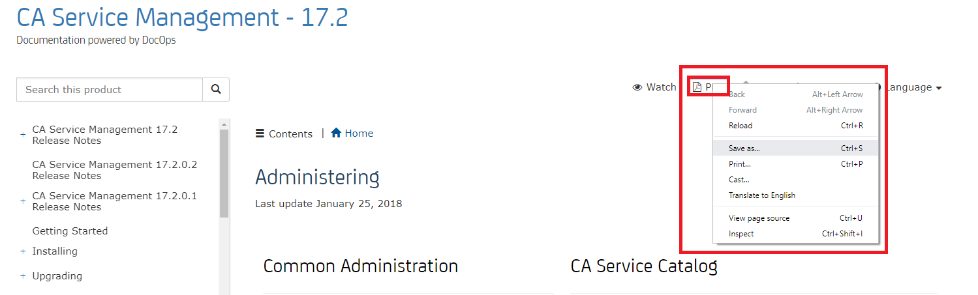

Here the “Installation” section has been saved to the “Downloads” folder.
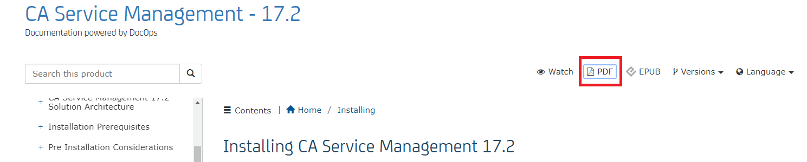

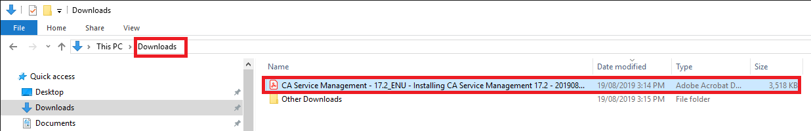
Continue until all of the required sections have been downloaded.
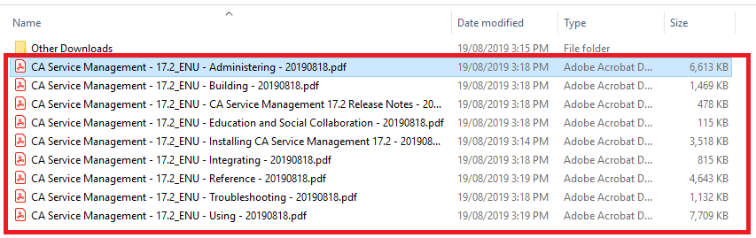

4. Merge each PDF into one.
This is an optional step, but it can make document searching easier. It is not necessary.
Use your PDF Merge tool of choice. Here, I have used “Smallpdf” - but you may use any you wish.
https://smallpdf.com
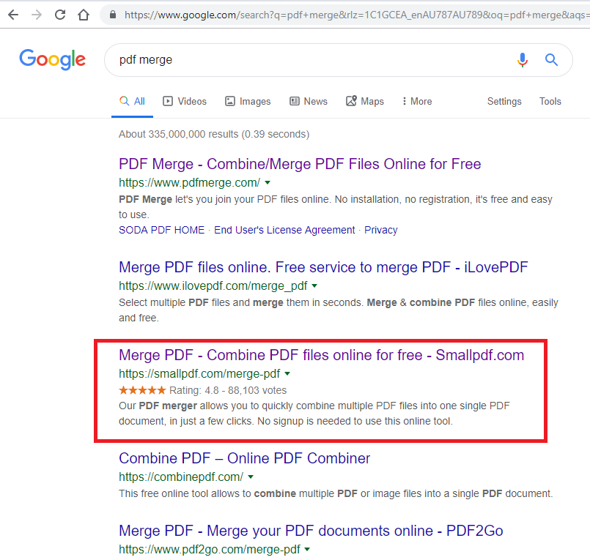

Simple drag and drop each file into the merger. Then click “Merge PDF!”
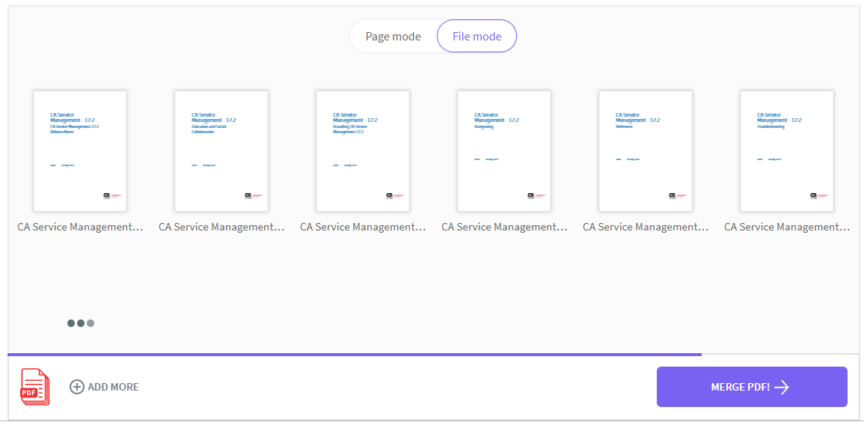

5. You now have a single merged PDF file

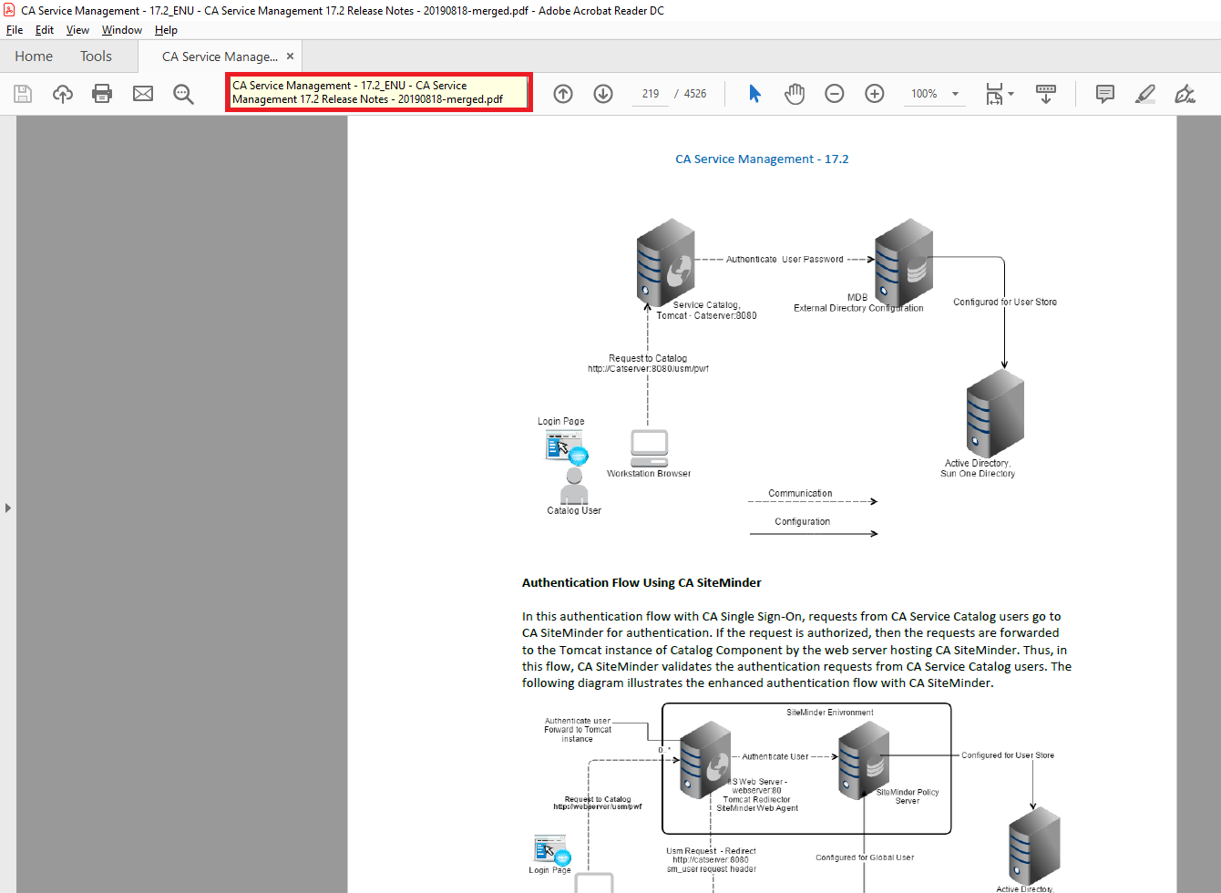

6. Search the PDF in a PDF Reader

Search either in one of the individual documents that was downloaded, or search against the single “merged” document.
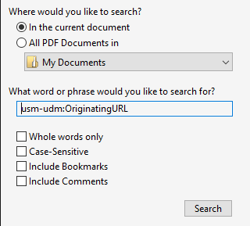
The results are found in the left pane, and you can jump to the relevant page which is displayed in the right pane.
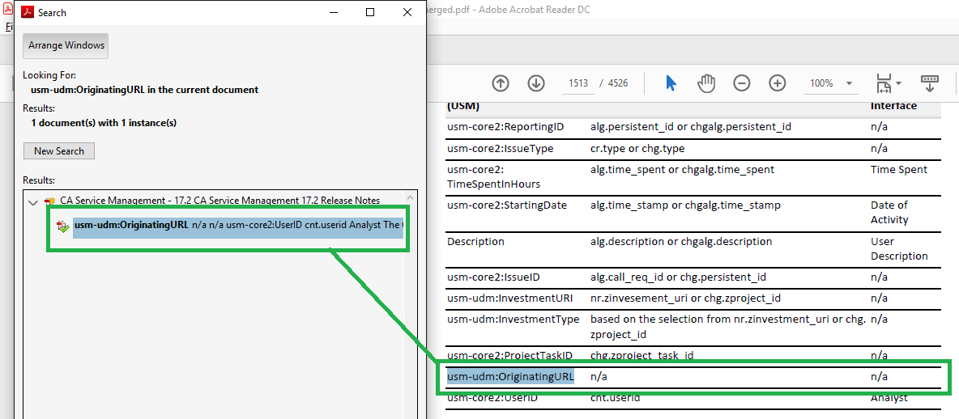

End of document.

