User Administrator/Site Administrator takes on the responsibilities of approving, updating and revoking access for the user at specific support site id. Requests for access to a site will be routed to the User Administrator instead of to Broadcom Customer Care. Once you become a user administrator, please follow the steps to manage permissions for a user.
NOTE: Broadcom Support recommends end-users having at least one Site Administrator assigned to each of their organizations Support Site IDs which provides them additional self-service capabilities outlined in this article.
If a Site Administrator is not assigned to an end-users Support Site ID, all access and role requests will be processed by Broadcom Customer Care.
Processing a pending request as a User Administrator:
Login to Broadcom Support Portal and once logged in, From the Dashboard
- Click on My Tools and select Administration.
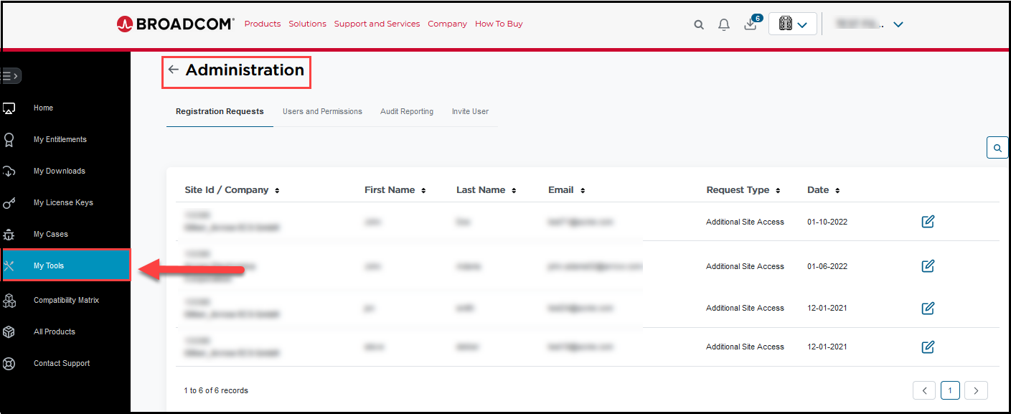
2. Select Registration Requests Tab. This will show all the pending requests associated with the site and to process it, click on Pencil Icon under EDIT/VIEW.
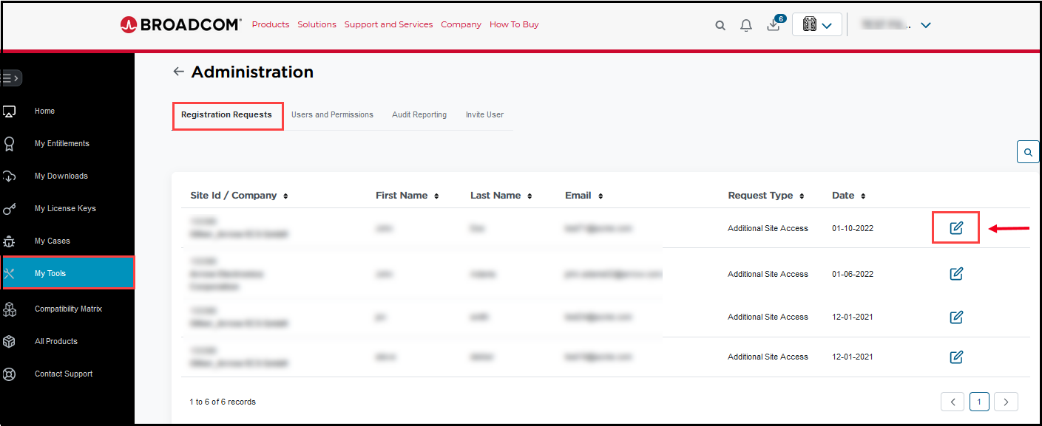
3. It will show you the request details. Choose the option Reject or Approve
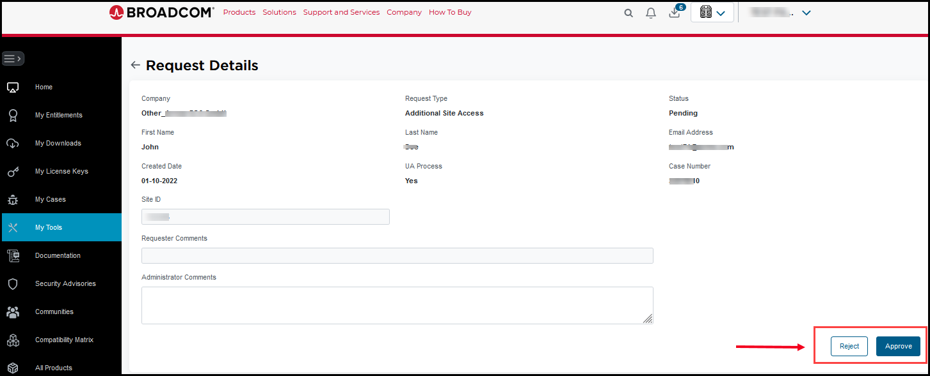
4. The requester will receive a system-generated email about the status of their request.

- Managing site ID permissions for a user as a User Administrator:
User administrators can log in to the support online portal and view the list of users associated with the sites. Admins will have access to change permissions from Enterprise to the below options:
- Enable/Disable Download
- Enable/Disable Licenses
- Enable/Disable Case Management Access
- Add/Revoke Site Access
- Add/Revoke Site Administrator Access
- Add/Revoke Subscription Manager
Note: Once you apply restrictions to a user, this permission will apply to any other site ID's the user is associated to.
To make changes to user's permission, please follow the steps mentioned below:
- Go to My Tools and select Administration.
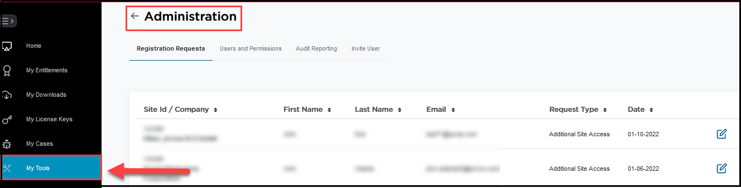
- Select “User and Permissions” tab. Use the filters and click on Show results.
Two new Role filters have been added allowing the Site Administrator to easily filter on those end-users assigned the Subscription Manager and Site Administrator roles.
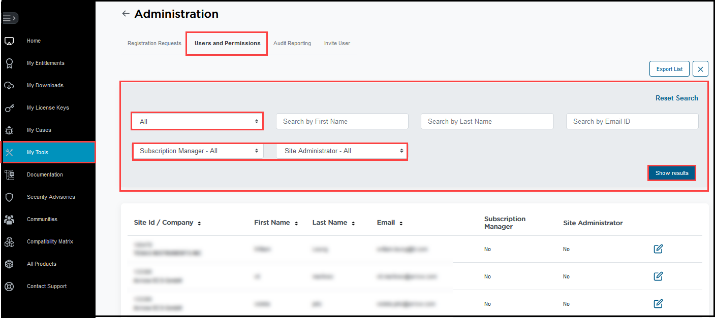
- Click the edit pencil icon next to any end-user row to open the new User Details page.
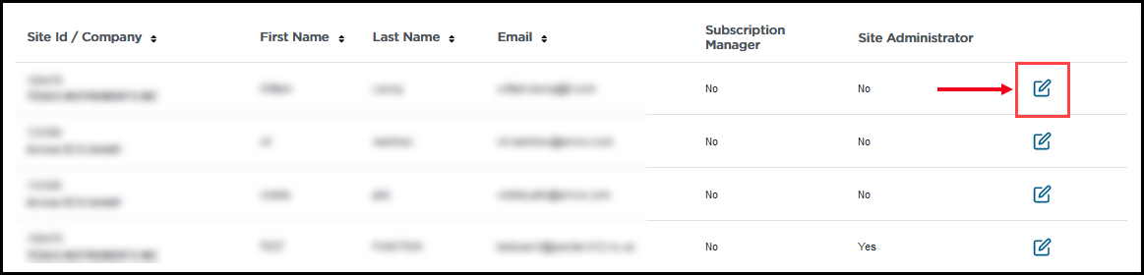
4. User Details view displays a breakdown of the end-users site ID associations and systems access (Downloads, Licensing, Case Management) and role assignments (Site Administrator, Subscription Manager).
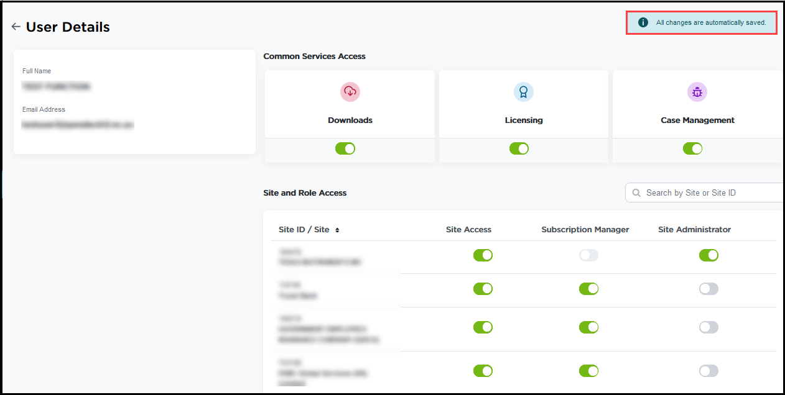
5. Revoking Site Access will remove the users access to that site along with the ability to raise cases against products associated with that site ID.
NOTE: Site Administrators should take note before proceeding, This action cannot be undone.
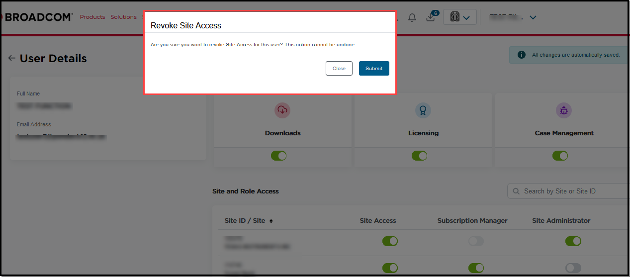
6. Adding/revoking access to Downloads, Licensing or Case Management will modify the users access across all their site ID associations.
NOTE: The Site Administrator cannot revoke access to these systems at the individual site ID level.
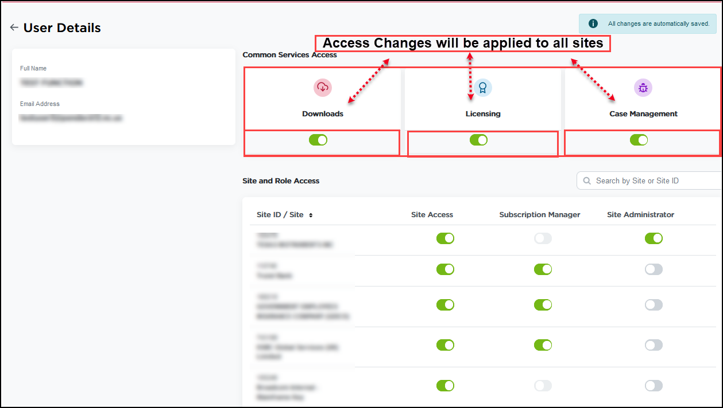
7. When the end-user attempts to click on a revoked system tile (Product Downloads, Licensing or Case Management) they’ll be redirected to a message indicating this functionality has been disabled by their Site Administrator.
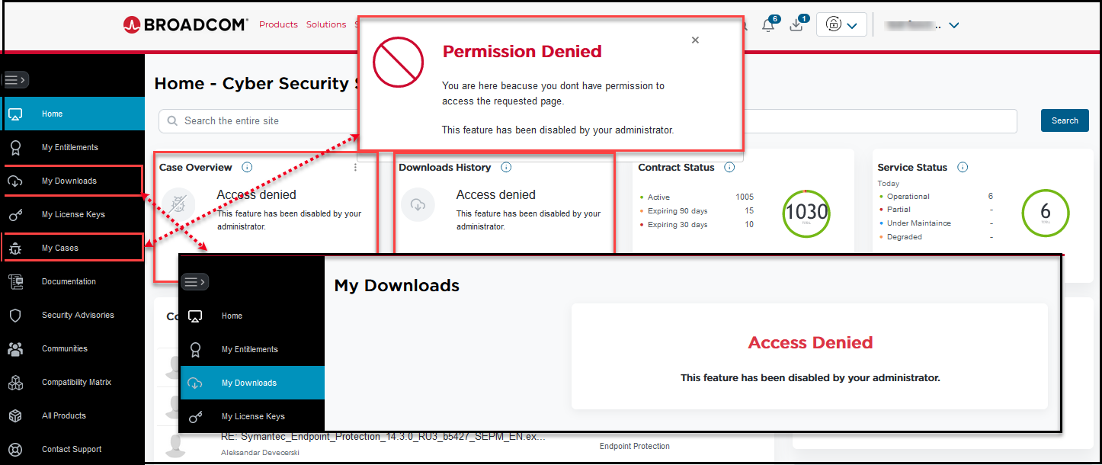
8. Revoked Product Download and Licensing access will be blocked at the appropriate tile level as well as the Download or License button via the My Entitlements Portal.
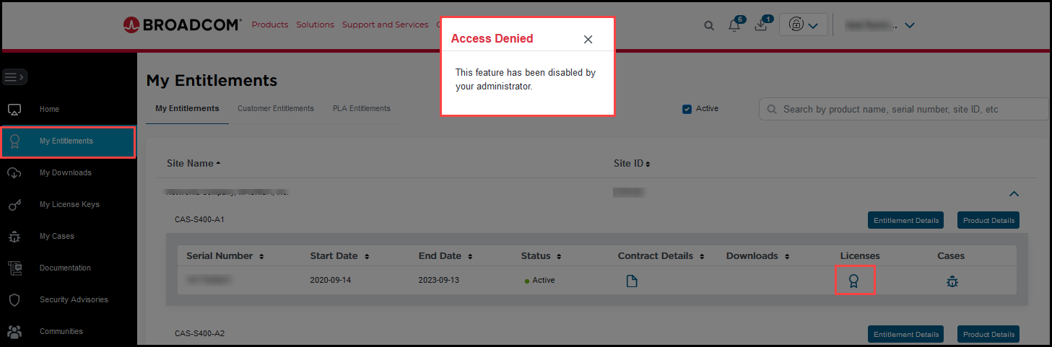

9. The Site Administrator role can be controlled at the individual site ID level, whereas the Subscription Manager role is applied to all PLA site IDs (non-PLA site IDs are greyed out).
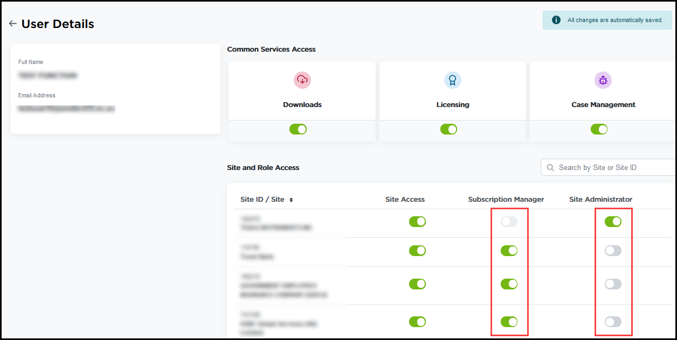
As system and role access is adjusted by the Site Administrator, changes are applied to the end-user profile immediately and individual email notifications will be triggered indicating their profile has been updated.
NOTE: The Site Administrator should be mindful of making a large number of changes at once as the end-user will receive individual notifications for every change made to their profile.
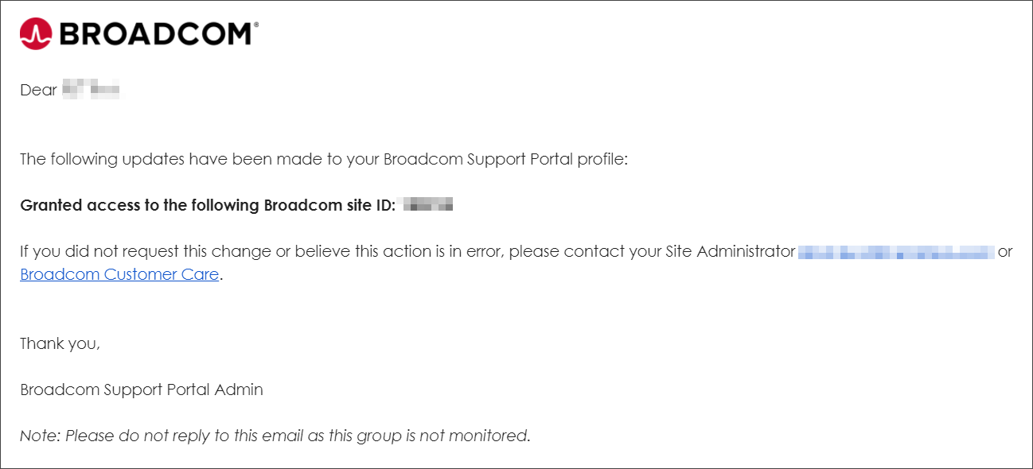
Audit Reporting
Click the Audit Reporting tab to view a list of all the end-user profile changes include who made the change and to what system or role.
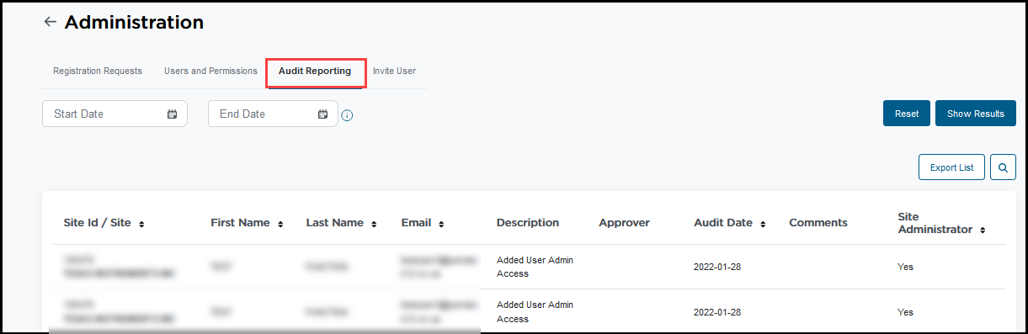
Inviting an Enterprise user to a site ID
Click the Invite User tab, enter the site ID of which you are a Site Administrator on, the email address of the end-user you'd like to associate the site ID to and click Submit.
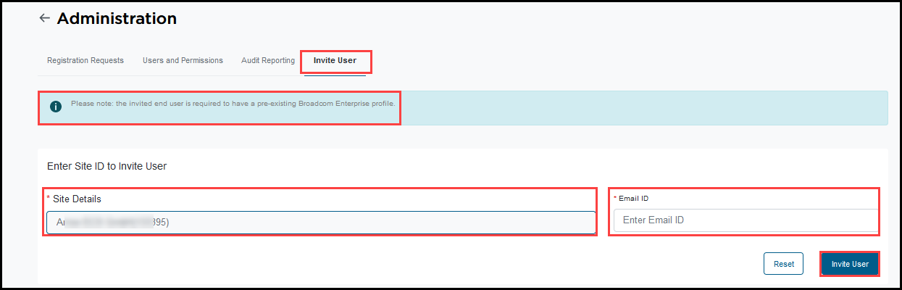
The end-user will receive a email notification indicating their profile is now associated with the site ID. They will now be able to manage support products (create cases, download software, generate license keys) under that site ID.
Removing your own User Administrator Access:
To remove your own User Administrator access, if there is another User Administrator at your site, request that they remove your access using the function described above. If you are the only User Administrator at your site and there will be a replacement, it is recommended that you first approve the replacement User Administrator, then request that person to revoke your access. If there will not be a replacement User Administrator and you are the only UA at the site, please open a support issue either online by selecting "Support Portal" as the product or by submitting your query using Customer Care Webform.
If you need any assistance, please contact a Broadcom Customer Care Representative by submitting a request using a Webform.
Related Knowledgeable - https://knowledge.broadcom.com/external/article?articleId=142905
Updated by @Ravi Kumar on 17/Feb/2022
​

